Progress Report I - Has government subsidies contribute to Broadband Deployment in rural areas?

We are interested in how broadband deployment has been evolving over recent years. In this analysis, broadband means to have all broadband services with a minimum download speed of 25 Mb/s and a minimum upload speed of 3 Mb/s. Alaska and Hawaii are excluded for analysis because they have very high installation and deployment costs.

First, we focus on the general national level deployment. Number of census blocks that have broadband deployed have steadily increased from 5.8 million to 8.5 million over the years from 2015 to 2021. Figure 1 shows the national level deployment rate, which is computed by dividing total number of blocks that have deployment with total number of blocks. This deployment rate has been increasing consistently from 52.7% to 77.5% over the past 7 years, where the average annual increasing rate is 7.8%.

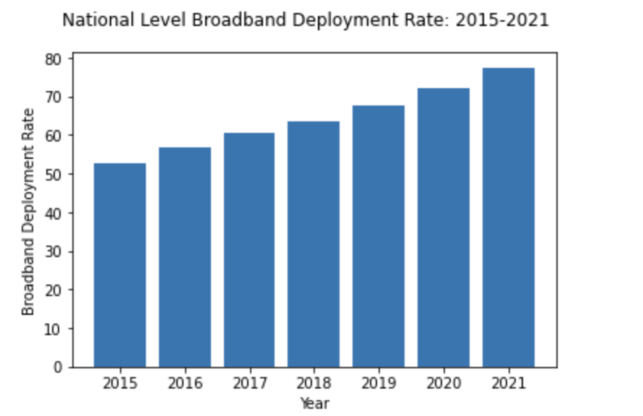

Figure 1: National level Broadband deployment rate

After getting a general idea about the national level, we then focus on the state level to find how deployment rates have been changed for each state. State-level deployment rate is computed by the number of census blocks that have broadband deployed within the state divided by the total number of blocks in that state. After computing the deployment rates, we show values on a map.

Figure 2 shows the deployment rate map in 2018. Generally, the east and west coast have higher deployments rate than the middle-west part. Major cities in the east and west coast generally have higher deployment rates.

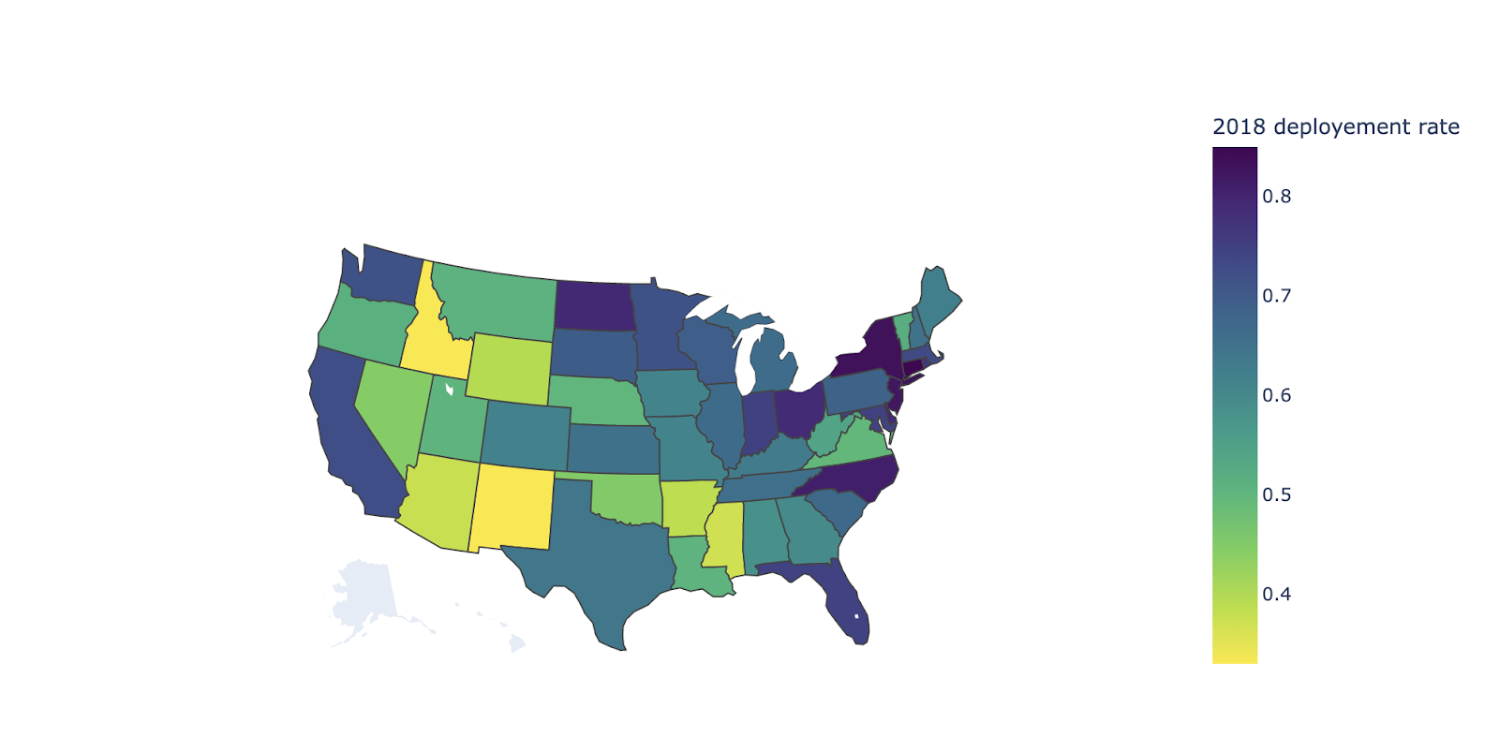

Figure 2: 2018 State-level Deployment Rate

We want to investigate how county level deployment rate is dependent on demographic and geographic features. County level deployment rate is calculated by the number of census blocks that have deployment in the county divided by the total number of blocks in that county.

From the correlation matrix in Figure 3, we observe that top 5 important features correlated to county-level deployment rate are Rural_density, Status_own_density, Race_white_density, Age_between_5_and_17_density and Race_native_hawaii_and_other_pacific_island_density.

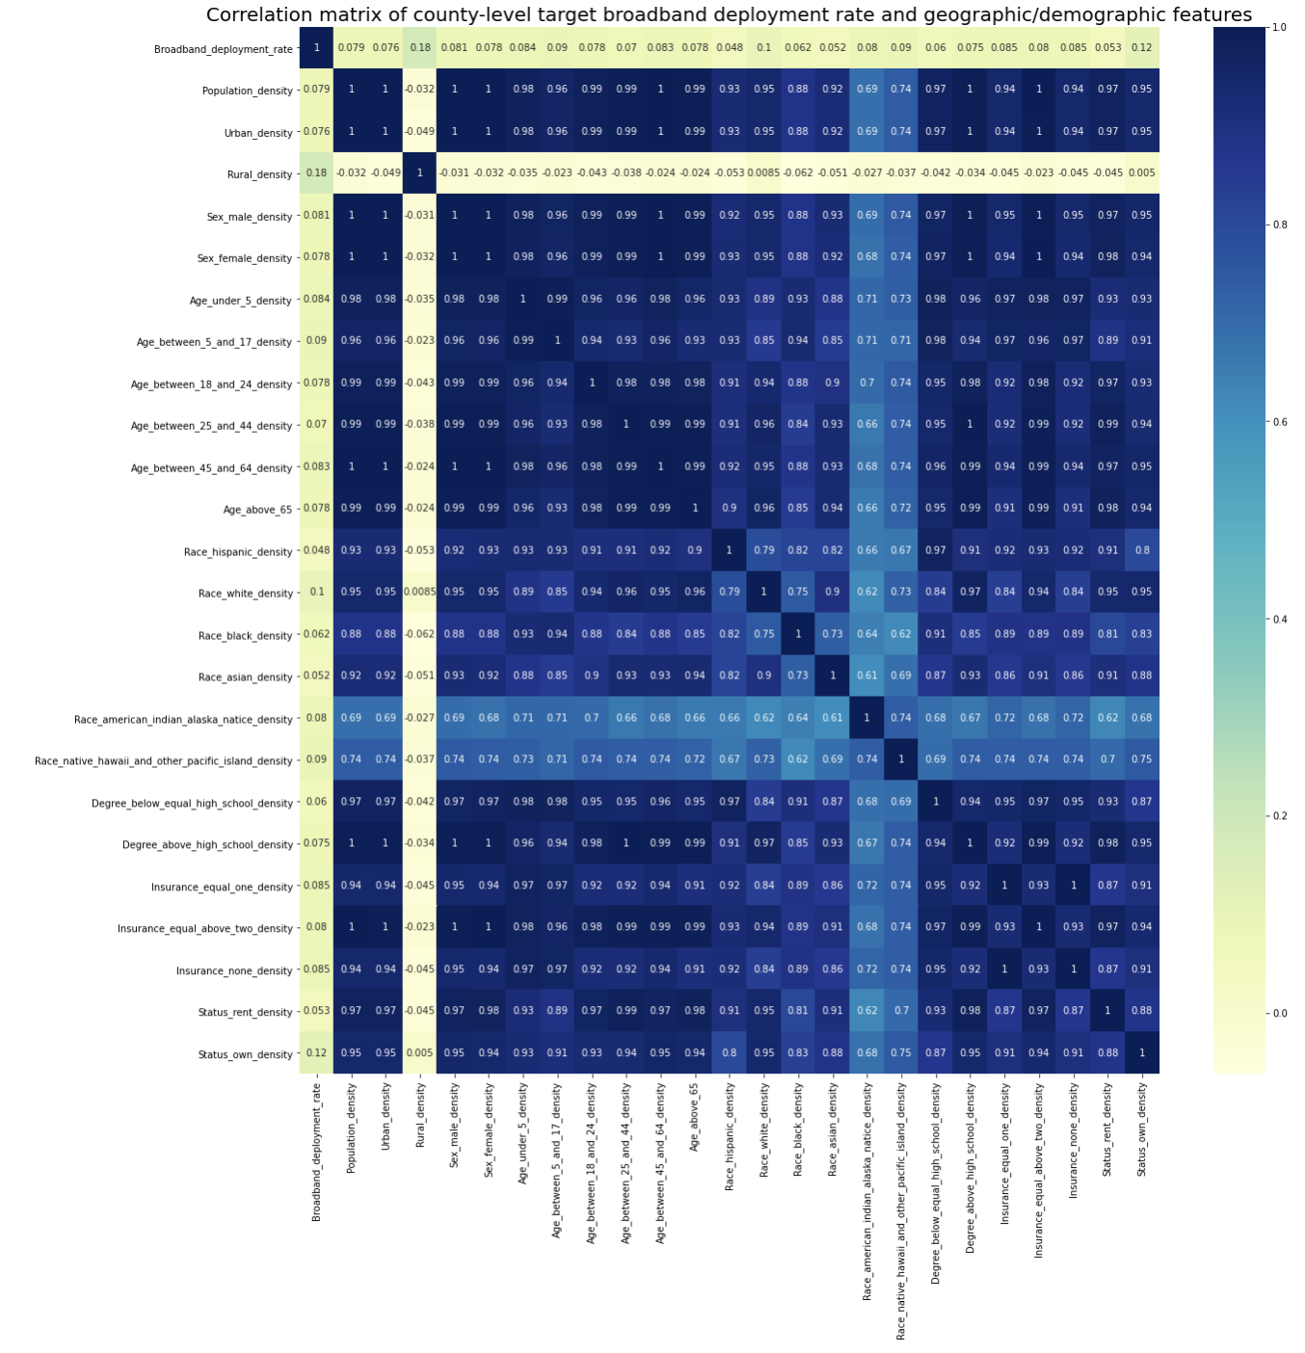

Figure 3: Correlation matrix of county-level target broadband deployment rate and geographic/demographic features

Linear regression model is fit on the data to see how the target variable  deployment rate is related to features. From table 1: Linear regression coefficient on features, we find that top 3 features that are positively related to target variable are Age_under_5_density, Rural_density, and Race_native_hawaii_and_other_pacific_island_density. And top 3 features negatively related to target variable are Race_american_indian_alaska_natice_density, Age_between_25_and_44_density, and Age_between_45_and_64_density.

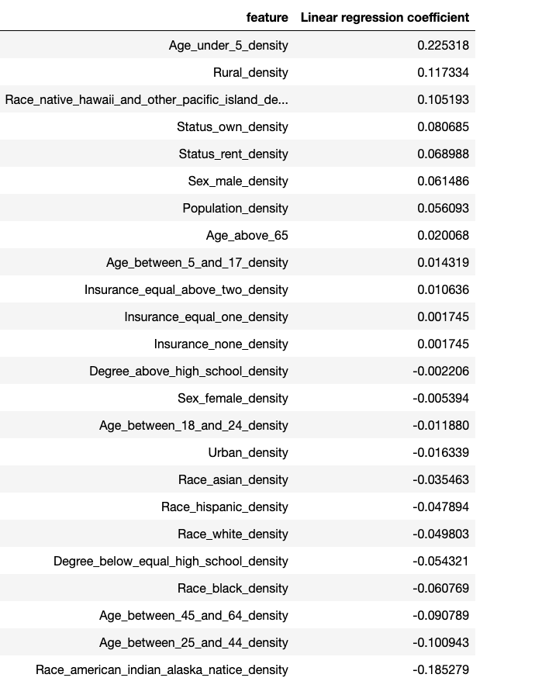

Table 1: Linear regression coefficient on features

Contribution:

* Shengyuan Cao:

Processed national level and state level broadband deployment rate data based on census blocks. Visualized deployment rate changes over recent years on graphs. Investigate relationship between county-level deployment rate and demographic and geographic features by creating a correlation matrix and fit a linear regression model.